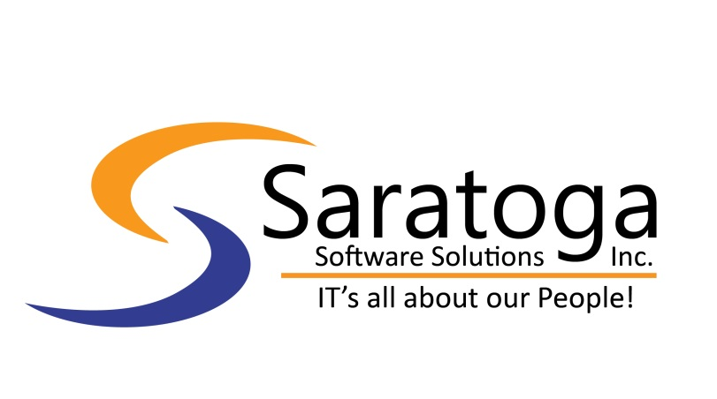
450 Century Parkway Ste. 250
Allen, TX 75013-8044
Office: (469) 301-1515
TeamSaratoga.com

Request ID: 2201003
Duration: Contract to Hire / 12 months (probable extension)
Position: Sr. Product Owner

Description: The Sr. Product Owner is the member of the Agile Team who serves as the customer proxy and is responsible for working with Product Management and other stakeholders—including other product owners and other teams—to define and prioritize the Team Backlog so that the solution effectively addresses program priorities while maintaining technical integrity. The Sr. Product owner also attends product management meetings, planning, and backlog/vision refinement sessions. The Sr. Product owner serves a mentor to the APO and PO.

- Leads preparation of backlog for PI Planning and decides which work items become part of the team backlog
- Serve as the customer proxy
- Define, prioritize and review the team backlog
- Facilitates and leads in Scrum ceremonies such as iteration planning, iteration reviews, and demos
- Help create user stories and define acceptance criteria
- Review and accept user stories as complete
- Lead in defining vision and program backlog
- Meet with stakeholders to ensure features and subsequent stories meet expectations
- Review, approve and drive iteration content by prioritizing user stories
- Knowledge of Risk and Compliance initiatives including PCI, SOX, HIPAA

Required:
- 5+ years of Product Owner / Project management / Analysis experience
- Experience managing projects in a Scrum environment.
- Ability to scale and work across multiple product lines
• Ability to make decisions independently and help mentor other Product Owners
• Organized with strong attention to detail and capable of coordinating multiple viewpoints into a single message
• Expert ability to understand technical issues
- Experienced analytical and problem-solving skills with a high attention to detail
- Proactively shows initiative by anticipating risks, issues and opportunities, and escalating them accordingly, while mentoring and coaching.
- Excellent skills in presentation, facilitation, communication, and negotiation
- Expertise in Agile including the value and principles, and how they are applied in enterprise environments
- Must be comfortable and articulate in challenging change management scenarios, knowing when to insert self and when to fade back, while leading and mentoring juniors.

Preferred:
- Experience with Scaled Agile Framework (SAFe) preferred.
- Experience in the Identity Governance and Administration (IGA) space
- NetIQ tools (Micro Focus) specifically would be a plus (tools: Identity Manager, Identity Governance, Self Service Password Reset)
- Experience in the Directory Administration space (tool examples: Active Directory, eDirectory)
- Experience in the Access Management space (tools examples: Ping Identity, SecureAuth, Microsoft)
- Experience in the Privileged Account Management (PAM) space (tool examples: CyberArk, BeyondTrust, Thycotic)
- Knowledge of the NIST Cybersecurity Framework

